Using Rally Test Uploader.

Now you can upload testcases without CA Agile Central-Rally Plugin for excel by using the below template in XLSX Format with the correct input values can upload tests in Rally



Maintain the exact row-column reference in the provided template.

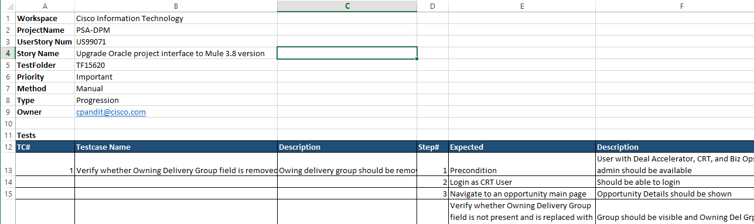

Steps to upload **tests** in Rally.

Create a blank test folder in Rally > Quality > Test Plan

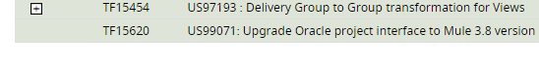

Download the above template and enter in the correct data and fill in the tescases

Extract and launch the RallyTestExecutor jar from the zip

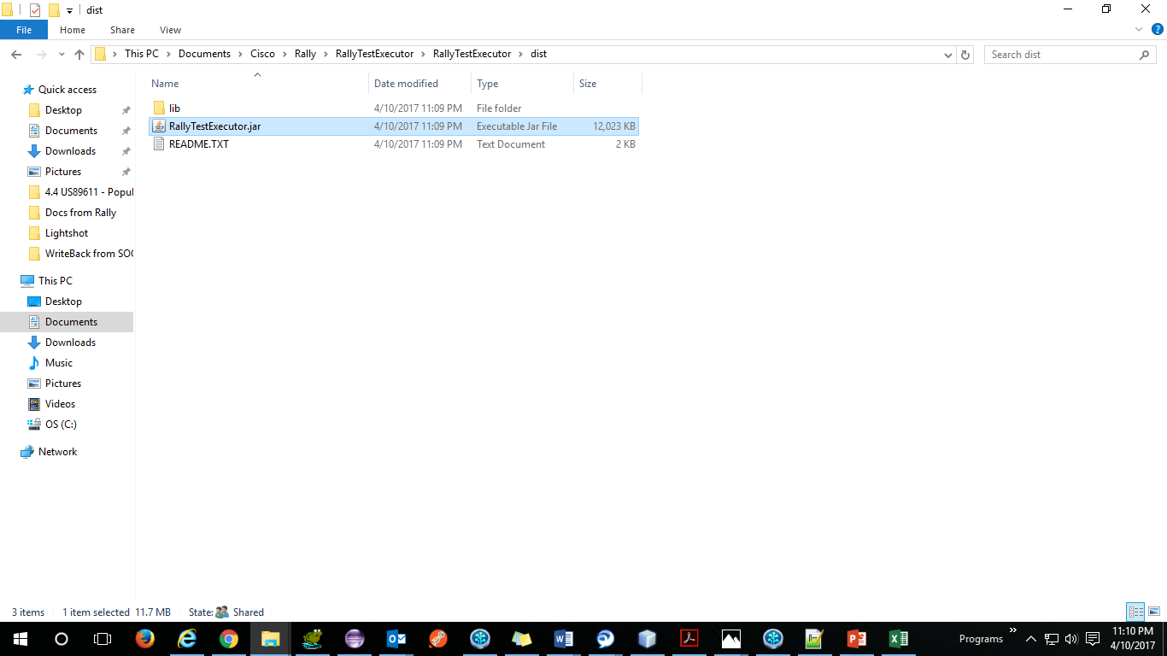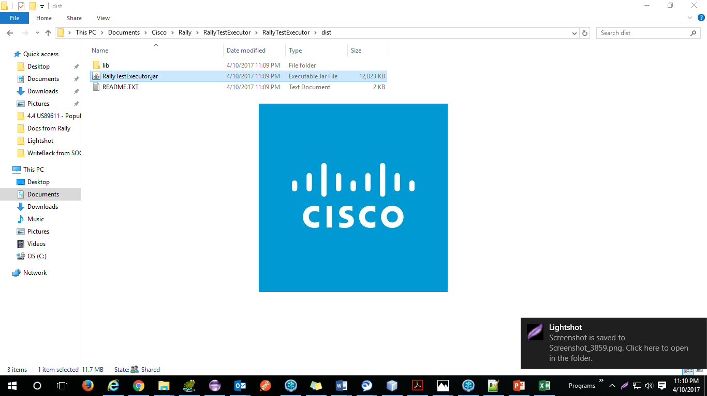

Click on Upload testcase button

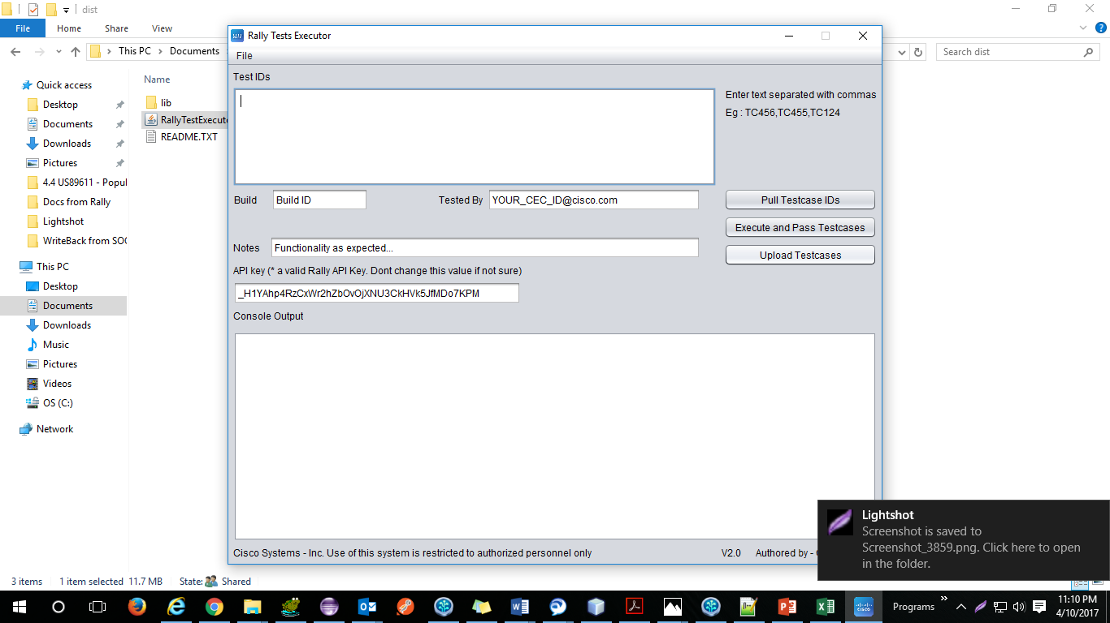

Or File > Upload Testcase

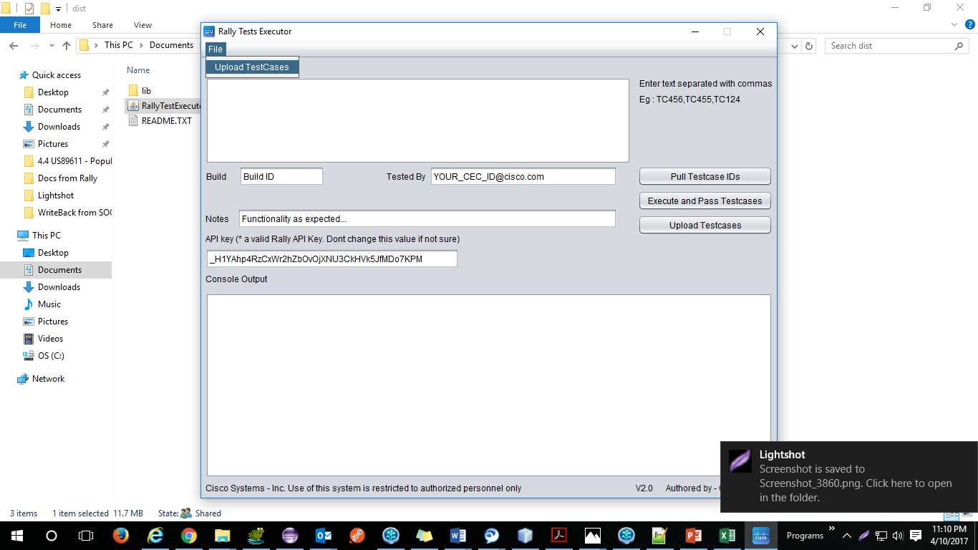

Click Choose Excel Template

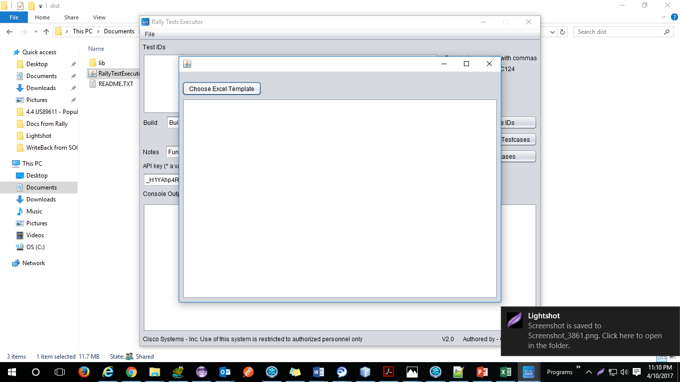

Choose the right template

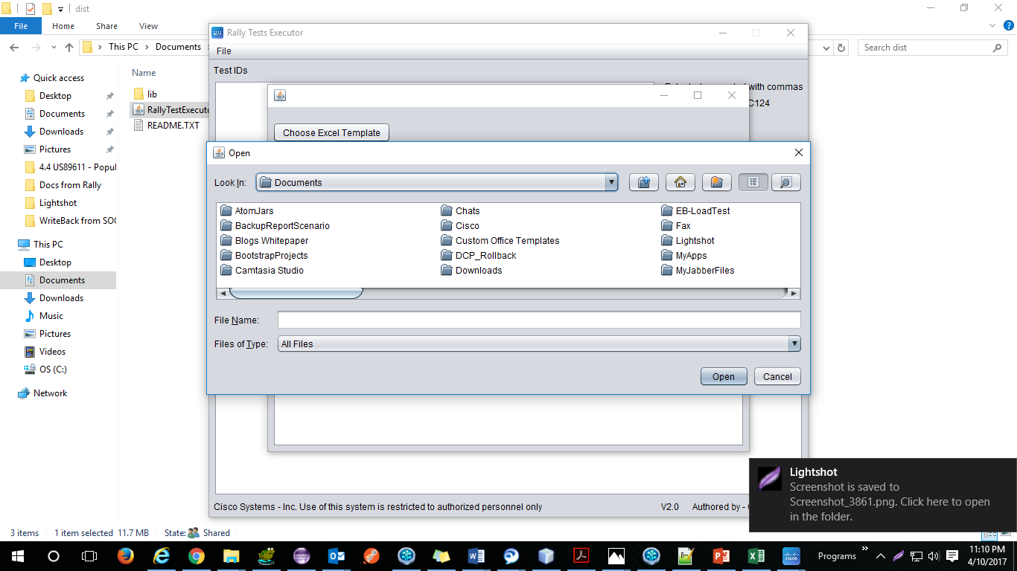

Select the template

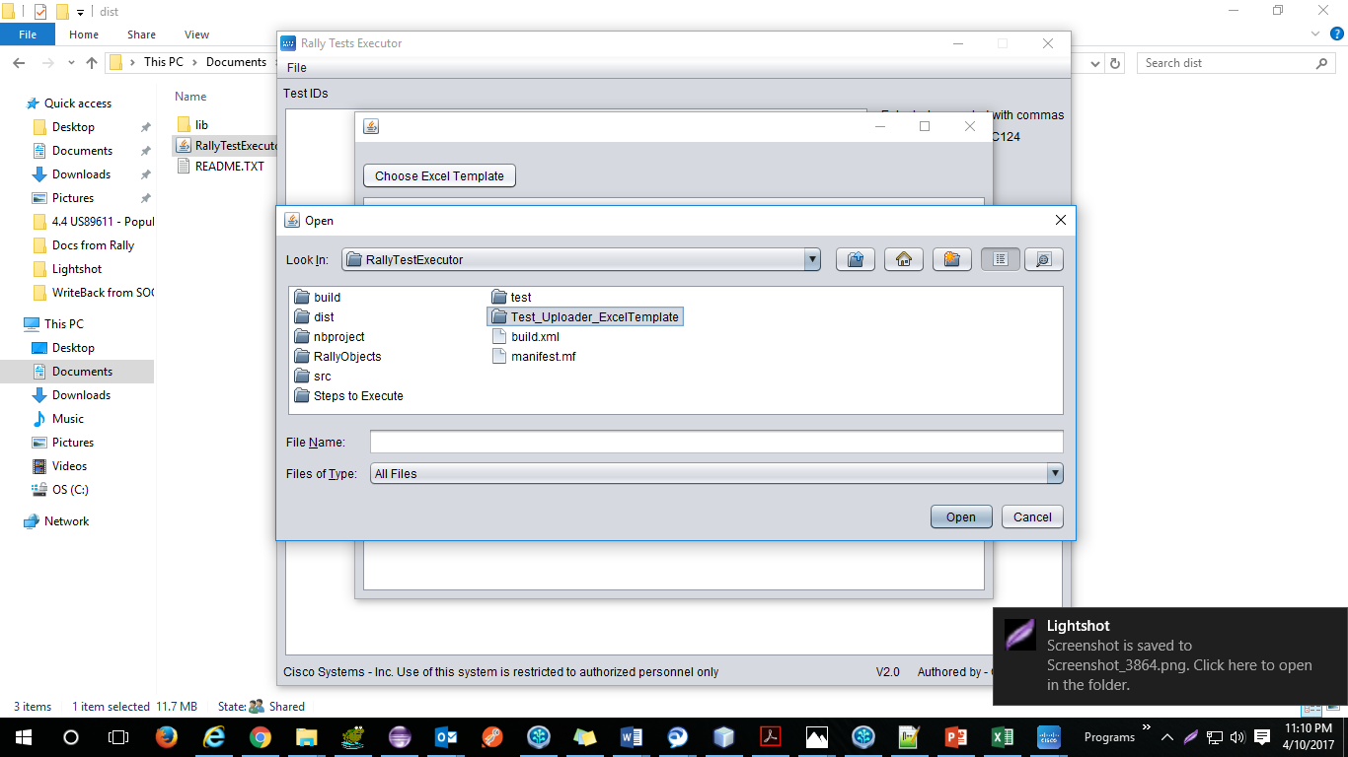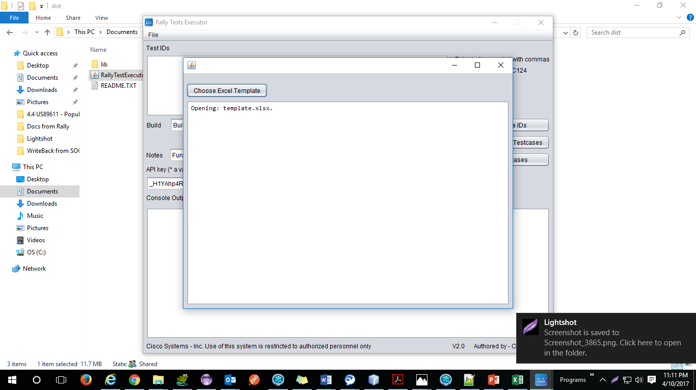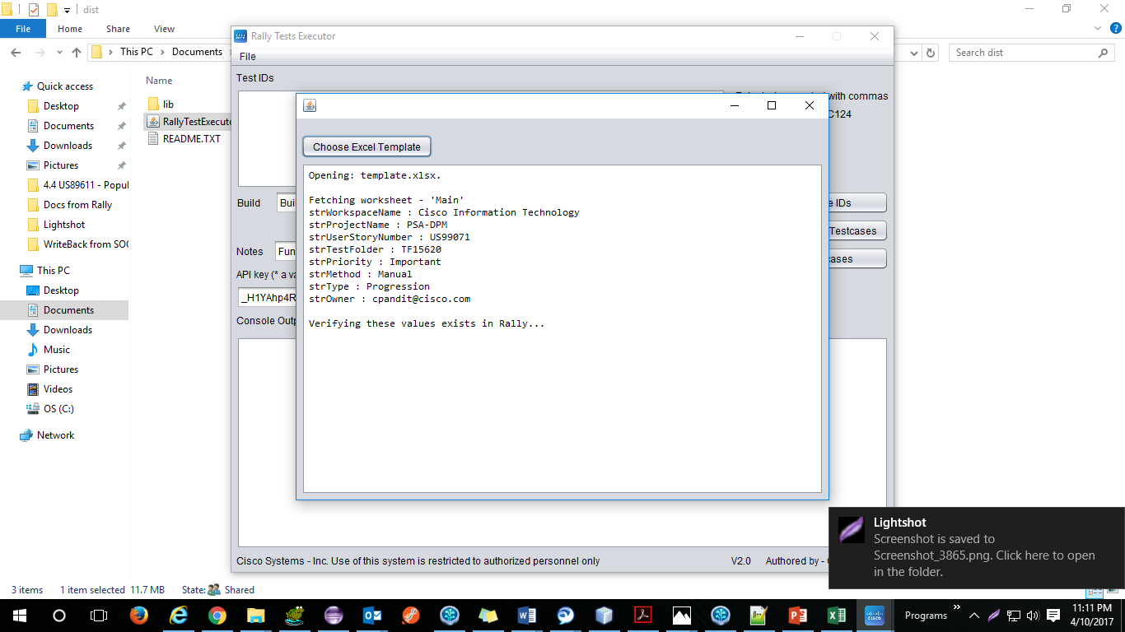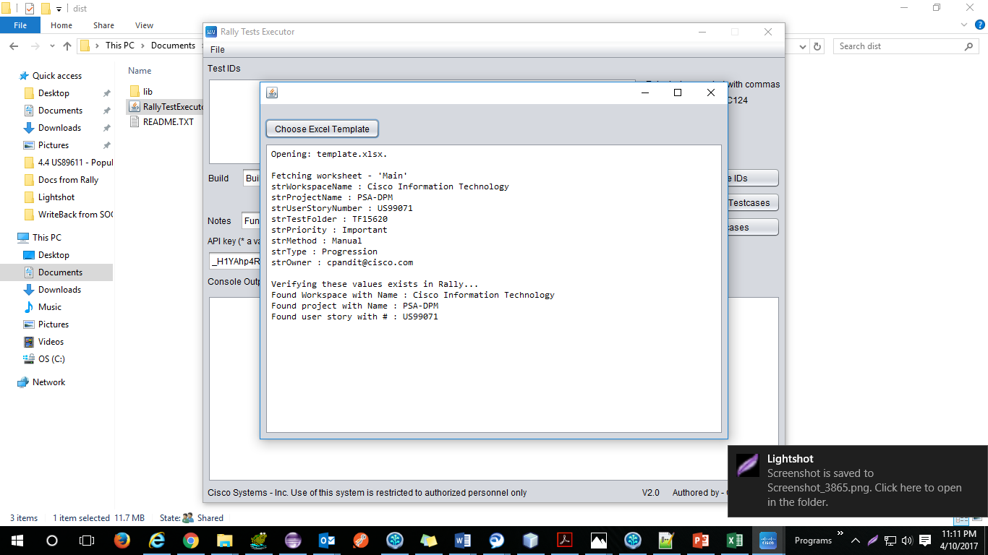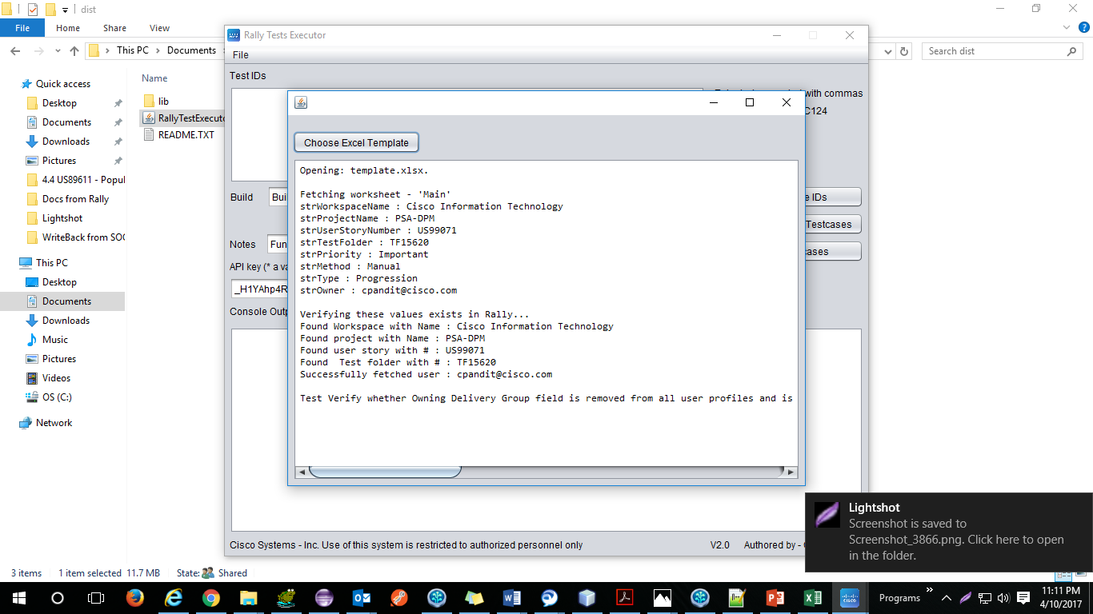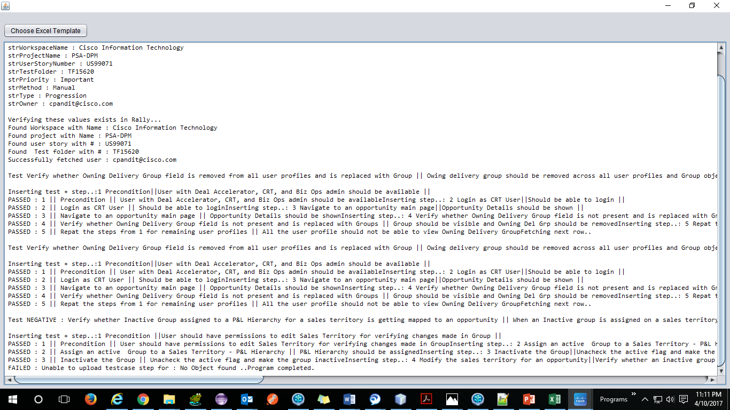

Once done – tests will be uploaded in Rally with same exact steps as mentioned in Template

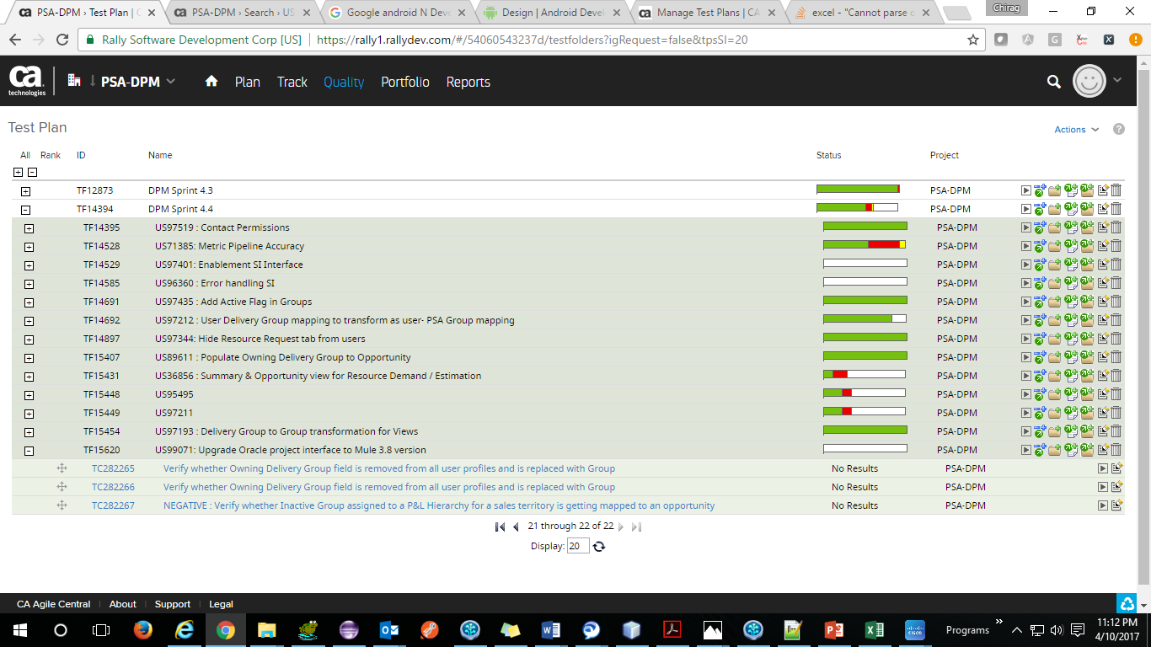

Opening the associated User story for verifying the test count

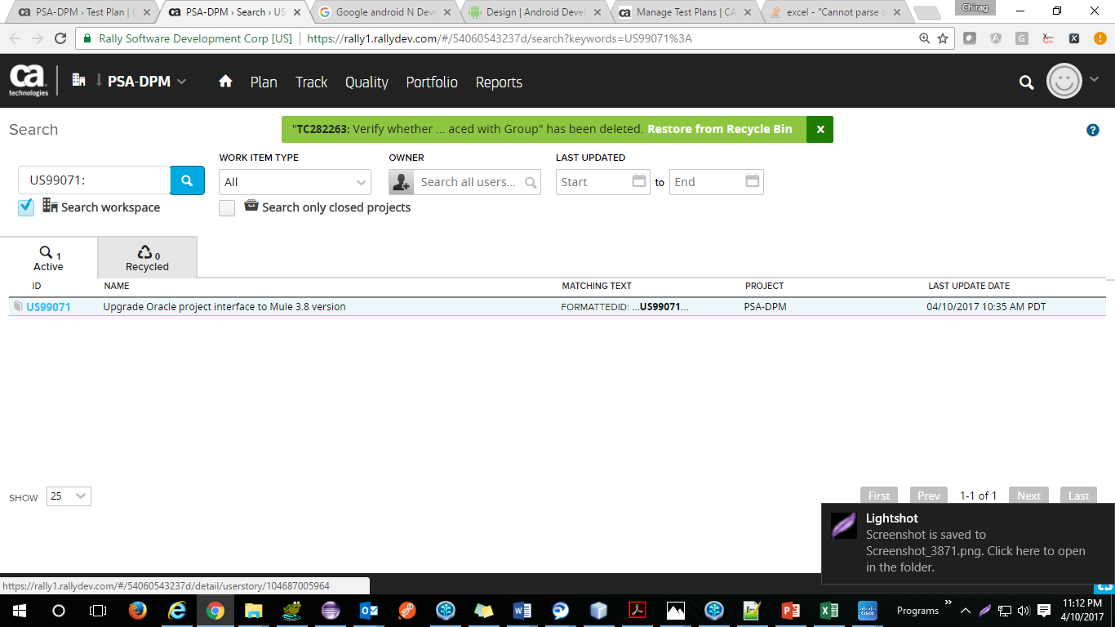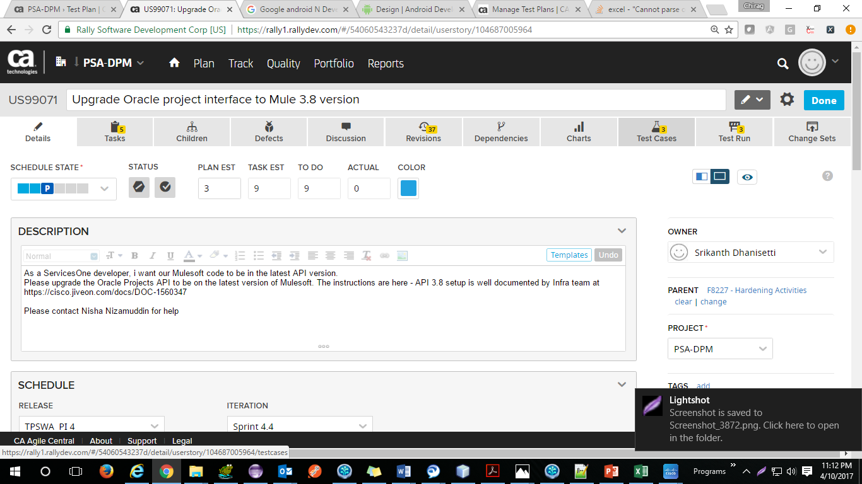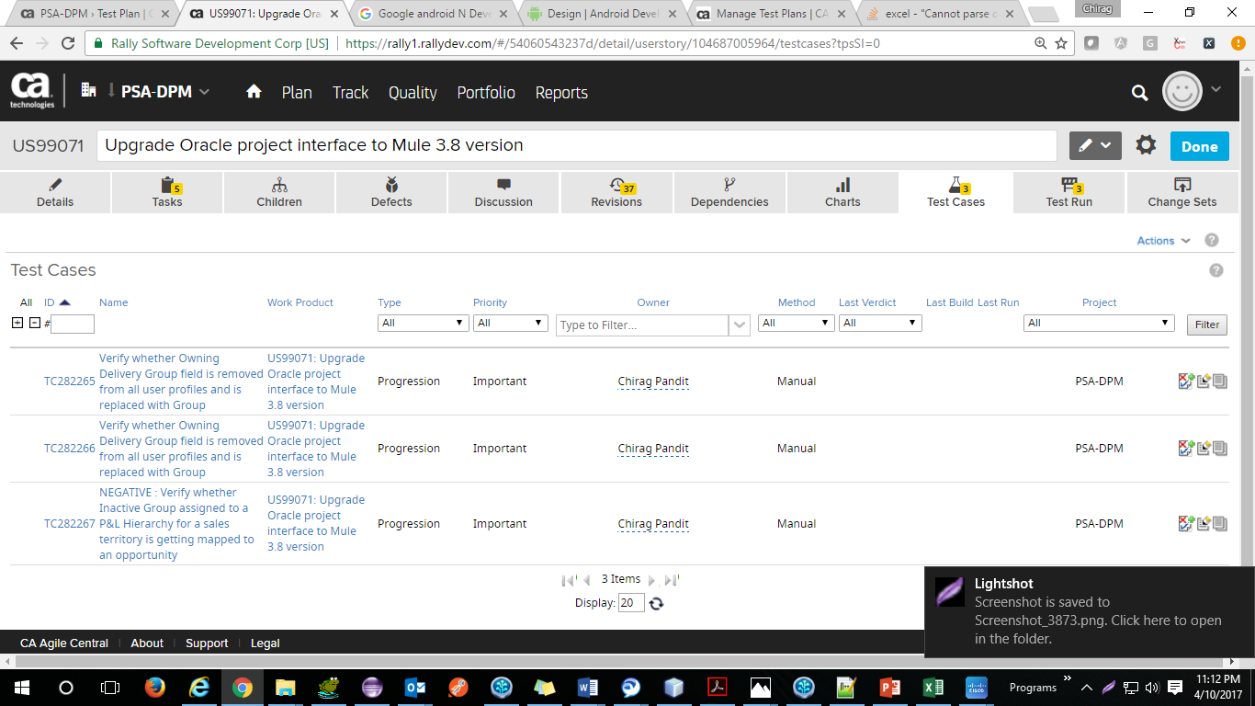

A look at the template. Maintain the same column / rows and try to replace special chars with their alphanumeric alternatives

